NEURAL NETWORKS

1. Neural Networks Overview
A neural network is inspired by the biological structure of the human brain. It consists of:
- Input layer: Accepts input features.
- Hidden layers: Performs computations using weights and biases.
- Output layer: Produces the final prediction or output.
Components of a Neural Network:
- Weights (www): Represent the strength of the connection between neurons.
- Biases (bbb): Shifts the activation function.
- Activation Function (f(x)f(x)f(x)): Adds non-linearity to the network.
- Neurons: Basic computational units that process inputs.

2. Forward Propagation
Forward propagation refers to the process of passing the input data through the neural network layer by layer to calculate the output.
Mathematical Representation:
For a single neuron:
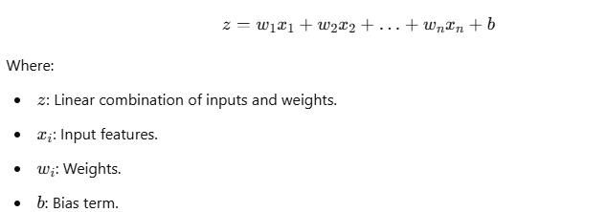
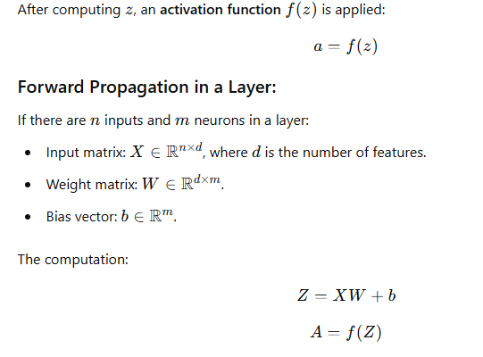
Intuition:
Forward propagation calculates predictions (ypred​) based on inputs and current weights. The output layer's activation determines the result (e.g., probability for classification tasks).
